Math 1309 Review for Test 1 – Spring 2012
Name:
This review is due at the time of the test. Show your work and use correct mathematical notation.

Topics covered in Test 1
- Limits: including limits at infinity and limits that are infinity, limits of piecewise-defined functions, and limits of exponential and logarithmic functions
- Continuity: values of x where a function is not continuous; intervals where a function is continuous, holes, jumps, and gaps
- Using limits to determine equations of vertical and horizontal asymptotes and locations of holes
- Limit definition of derivative, finding derivatives using the definition
- Power rule
- Product and Quotient rules
- Derivatives of exponential and logarithmic functions, using properties of these functions to simplify before taking the derivative
- Chain rule: power, exponential, and logarithmic functions

Practice Problems

1. Determine each of the following limits if they exist, or explain why they don’t exist.
a)* 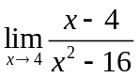 b) 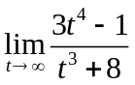 c)* 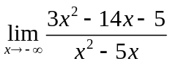 d) 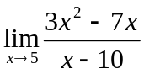
e) 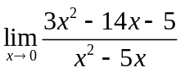 f) 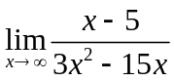 g)* 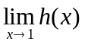 where 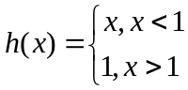
h)* 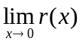where 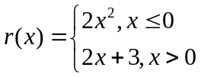 i) 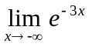 j) 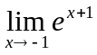 k) 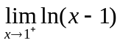 l) 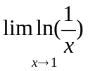
a) 1/8 ; b) ; c) 3 ; d)-8 ; e) ; f) 0 ; g) 1 ; h) does not exist; i) ; j) 1 ; k) ; l) 0

2. a)* Write the limit definition of 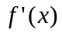
b) Use the limit definition to find the indicated derivatives. Show all your work.
i) 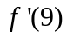for 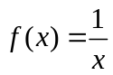 ii) 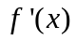for 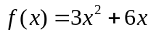
i) -1/81 ; ii) 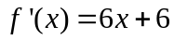

3. For each given function
a) Determine the values of x where the function is not continuous.
b) Use limits to find the coordinates of all the holes in the graph of f(x) and the equations of all the vertical and horizontal asymptotes. You must include the limits to get full credit for this question
i)* 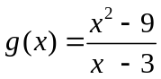 ii)* 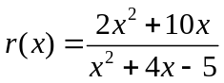

i) a) x = 3, g(3) is not defined (condition 2) ; b) Hole at (3,6), no horizontal asymptotes, no vertical asymptotes hole at (-5.5/3)
ii) a) x = -5 and x = 1, function is not defined (condition 2) ; b) hole at (-5.5/3), HA: y = 2, VA: x = 1

4. Find the derivative of each function
a) 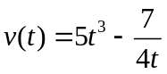 b) 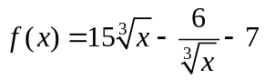 c)* 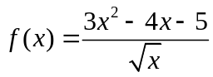 d)* 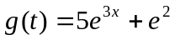

a) 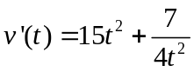 ; b) 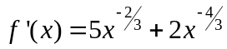 c) 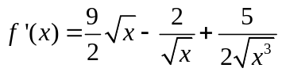; d) 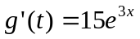

5. Determine the following derivatives
a)*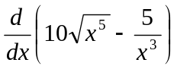 b)* 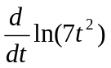 c) 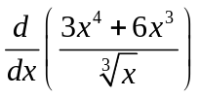
a) 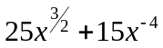 ; b) 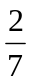 ; c) 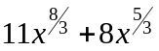

6. Use the product and quotient and chain rules to find each derivative
a) 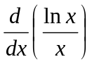 b)* 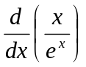 c) 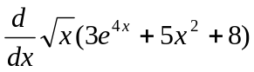 d)* 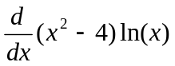 e) 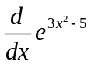
f) 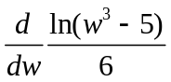 g)*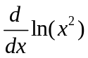 h)* 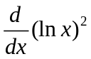 i)* 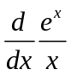 j)* 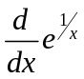

a) 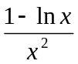 ; b) 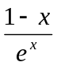 ; c) 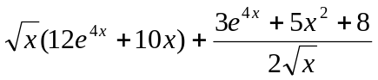 ; d) 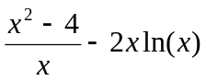 e) 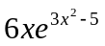
f) 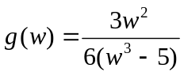 g) 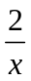 h) 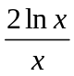 i) 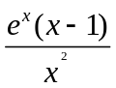 j) 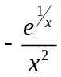

7. a) Find an equation of the tangent line to the curve at the given point.
b) Find the values of x for which the tangent line is horizontal (if any).
i) 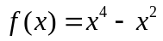at the point (1, 0) ii)* 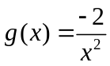at the point (2, -1/2)
iii) 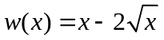at 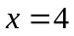
i) y = 2x-2, tangent line is horizontal at 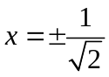 ; ii) y = ½ x – 3/2 , tangent line is never horizontal ;
iii) y = ½ x -2, tangent line is horizontal at x =1

8. Section 10.1, problem 15, 19*, 20* (limits from graphs)

9. Section 10.2, problems 1 – 4 (limits from graphs)

10. Section 10.3, problems 11e, 13e, 14e (continuity from graphs)

11. Section 10.7, problems 31, 37, 40 (Marginal Cost, Revenue, and Profit)

12. A company that manufactures ski jackets estimates that their fixed costs are $21,900 and variable costs of $24 per jacket. A survey indicates that a price of $140 results in a demand of demand of 300 jackets and that a price of $100 will result in a demand of 500 jackets.
a) Find the price-demand equation assuming a linear relationship
b) Find the revenue function and determine the domain its domain using the price-demand equation
c) Find the total cost function
d) Find the profit function and the marginal profit function
e) Evaluate the marginal profit at production levels of 300 and 600 jackets and interpret your result being specific about quantities, units, and increasing/decreasing

